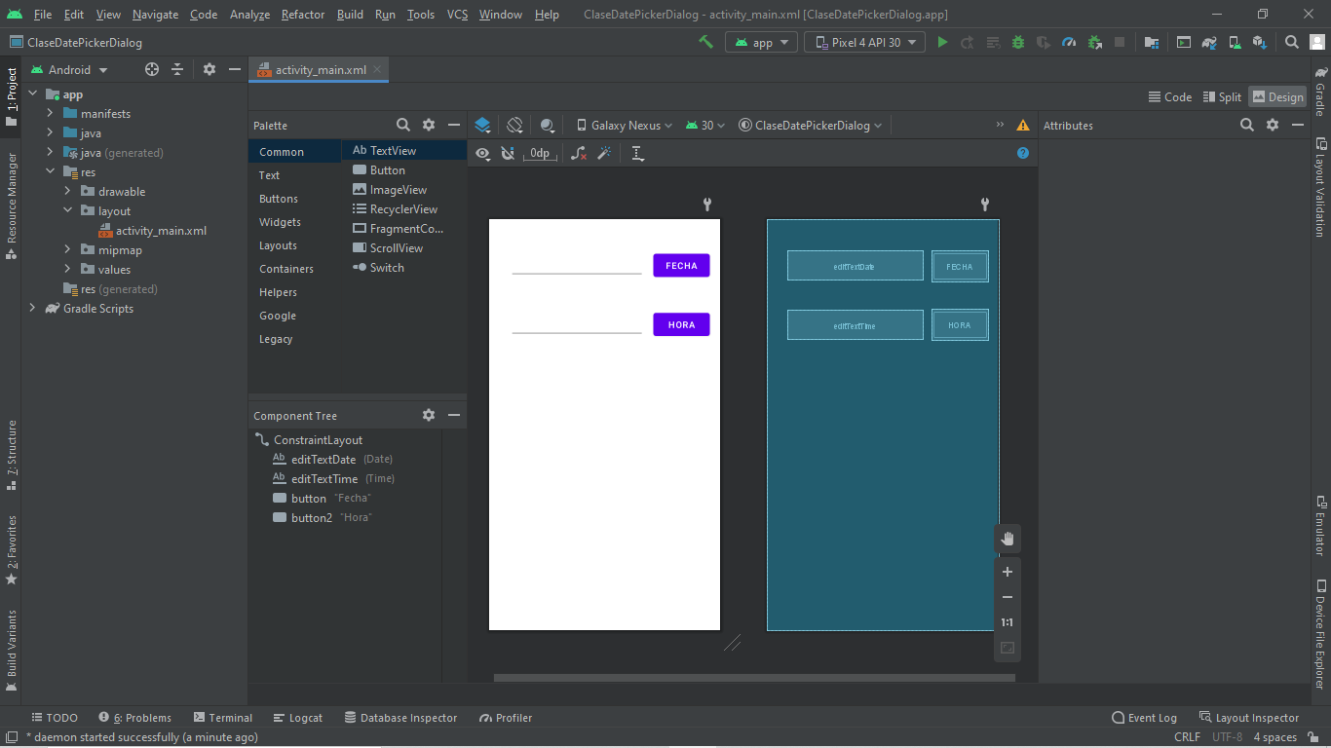

package com.lost.clasedatepickerdialog;
import androidx.appcompat.app.AppCompatActivity;
import android.app.DatePickerDialog;
import android.app.TimePickerDialog;
import android.os.Bundle;
import android.view.View;
import android.widget.DatePicker;
import android.widget.EditText;
import android.widget.TimePicker;
public class MainActivity extends AppCompatActivity {
EditText ed1, ed2;
@Override
protected void onCreate(Bundle savedInstanceState) {
super.onCreate(savedInstanceState);
setContentView(R.layout.activity_main);
ed1 = findViewById(R.id.editTextDate);
ed2 = findViewById(R.id.editTextTime);
}
public void mostrarFecha(View view) {
DatePickerDialog date = new DatePickerDialog(this, new DatePickerDialog.OnDateSetListener() {
@Override
public void onDateSet(DatePicker view, int year, int month, int day) {
ed1.setText(year + "/" + month + "/" + day);
}
}, 2021, 9, 9);
date.show();
}
public void mostrarHorario(View view){
TimePickerDialog time = new TimePickerDialog(this, new TimePickerDialog.OnTimeSetListener() {
@Override
public void onTimeSet(TimePicker view, int hourOfDay, int minute) {
ed2.setText(hourOfDay + ":" + minute);
}
},10, 30,true);
time.show();
}
}

